BWWB Online Customer Portal Guide
November 29, 2016
By: Mayuri Bhakta

Table of Contents
Tips 3
1. Migrated Users 4
2. Register for online account 5
3. Forgot Password or Username 6
4. “Action Cancelled, User Request is already completed” Error 6
5. Locked out from account 7
6. Multi-pay 8
7. Blue screen is being displayed 11
8. Link in email is not directing to homepage 11
9. Supported browsers 11
10. Enable/disable paperless billing 12
11. Customer wants to enable location services on their MacBook 13
12. Errors during registration 14
13. Recaptcha does not reload 15
14. Submitting Stop, Transfer or Start Requests. 16
Stop Request: 16
Transfer Request 17
Existing customer starting new services 19
New Customer starting new services 21

Tips
- Before answering any questions in regards to the online portal, always check the interaction record to see if that customer has an activated online account and then assist them with any questions they have. (They must click on the link before the interaction record is created)
- Customers will not be able to change their usernames, only passwords, contact information, payment information and mailing addresses can be updated through the online portal under the settings tile.
- Customers cannot merge accounts.
- Passwords can only be changed once a day.
- All passwords for new users registering online must contain 6 characters and of the 6 characters one must be a capital letter and a special character. If the customer is changing their password through the password reset link or the settings tab they do not have these restrictions.
- Always make sure that registering customers are only entering the PO Box or House Number for their MAILING address when submitting registration, password resets, or multipay and not their full address.
If customer calls in with questions regarding the online portal ask some of these questions below to assist the customer better:
- Did you receive an email from us with a username and password? If yes, please see number 1. If no, walk customer through registering online account, see number 2.
- Are you getting an error that says you are locked out of your account? If yes, please see number 5.
- Do you have multiple accounts that you need to pay for? If yes, please see number 6.
- Would you like to create an online account and make online payments? If yes, please see number 2. If no, customer can call in, walk in or submit guest payments.
- Are you seeing a blue screen? If yes, please tell the customer to clear their cache for the browser.
- What browser are you using? Please see number 9. If the browser is not on the list the online portal will not work. Suggest for the customer to try logging in on a supported browser from the list.
- Are you trying to enable/disable paperless billing? If yes, please see number 10.
- Did you receive an email in regards to your paper bill? If yes, please see number 10.

1. Migrated Users
(Customer calls in and says that they have received an email with a username and temporary password provided by us)
- Click on the activation link in the activation email
- Customers will be prompted to enter the user id/user name and the provided Temporary Password and click ‘Login’
- Customers will then be taken to a screen to enter their Temporary Password as well as create a New Password (entered twice) and then click ‘Change’
- Customers will then be logged into and see our new EasyPay Customer Portal
Customers would have received this email on November 15-16th:
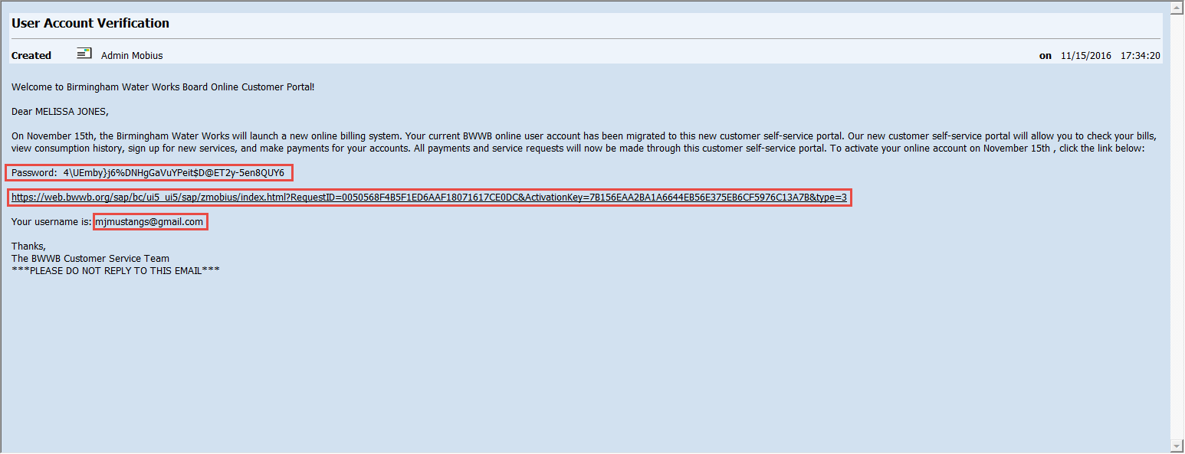
Customers would have received this email on November 18th:
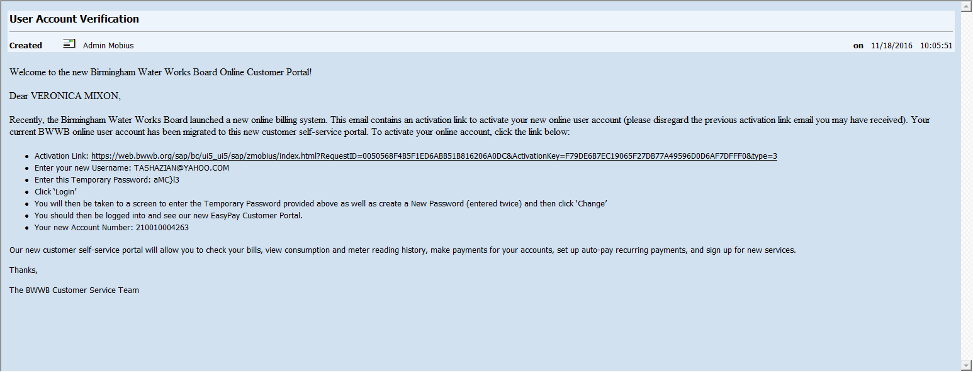

2. Register for online account
- Using their new customer account number (listed on their next bill received after 11/15/16 or obtained by calling the BWWB Customer Service Center at (205) 244-4000).
- Click on the following link, https://web.bwwb.org/myaccount
- Click on ‘Register for Online Access’
- Enter:
  - First Name
  - Last Name
  - Username
  - Account number
  - Password (entered twice)
  - Email address
  - PO Box/Street # (Please only enter the PO Box/Street # for mailing address - DO NOT enter street name)
- Click ‘Submit’
- Customers will then receive an activation email with an activation link
- Click on activation link in activation email
- Customers will be prompted to enter the user name and the password entered on the ‘Register for Online Access’ screen and click ‘Login’
- Customers will then be logged into and see our new EasyPay Customer Portal
- Once the customer has clicked on the link an interaction record will be generated in ICWEB and you will be able to see the customer’s user name in the notes section. (Screenshot below)
Customer will receive this email if they submit online registration themselves:
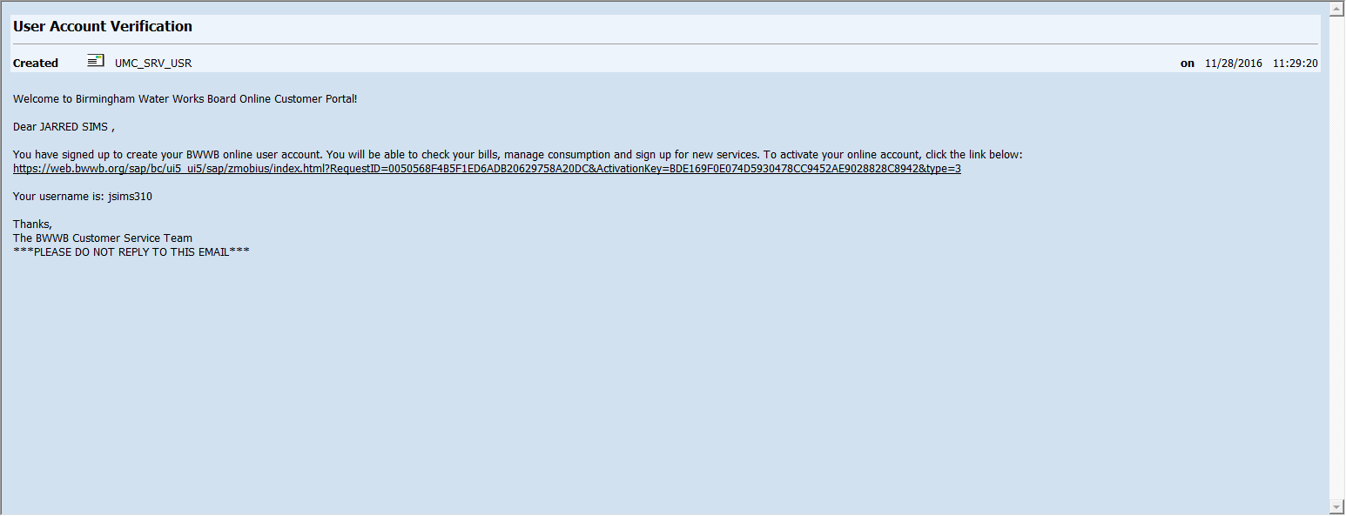
Interaction Record that is created once customer clicks on activation link from migrated email or from registering on their own:
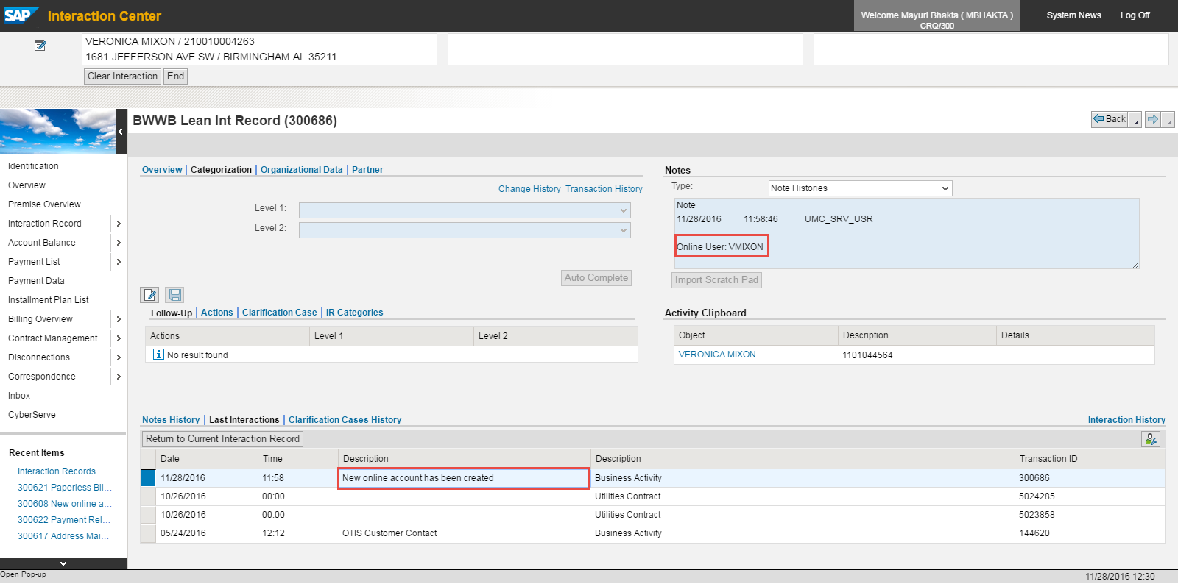

3. Forgot Password or Username
- Enter one of the following:
  - Username OR
  - Email address OR
  - Account Number and PO Box/Street # (Please only enter the PO Box/Street # for mailing address - DO NOT enter street name)
- Customers will then receive an email with a temporary password and an ‘Enable your new password’ link
- Customers should click the ‘Enable password’ link and then be prompted to enter the user id/user name and the provided Temporary Password and click ‘Login’
- Customers will then be taken to a screen to enter their Temporary Password as well as create a New Password (entered twice) and then click ‘Change’
- Customers will then be logged into and see our new EasyPay Customer Portal
Customers will receive this email if they submit password reset:
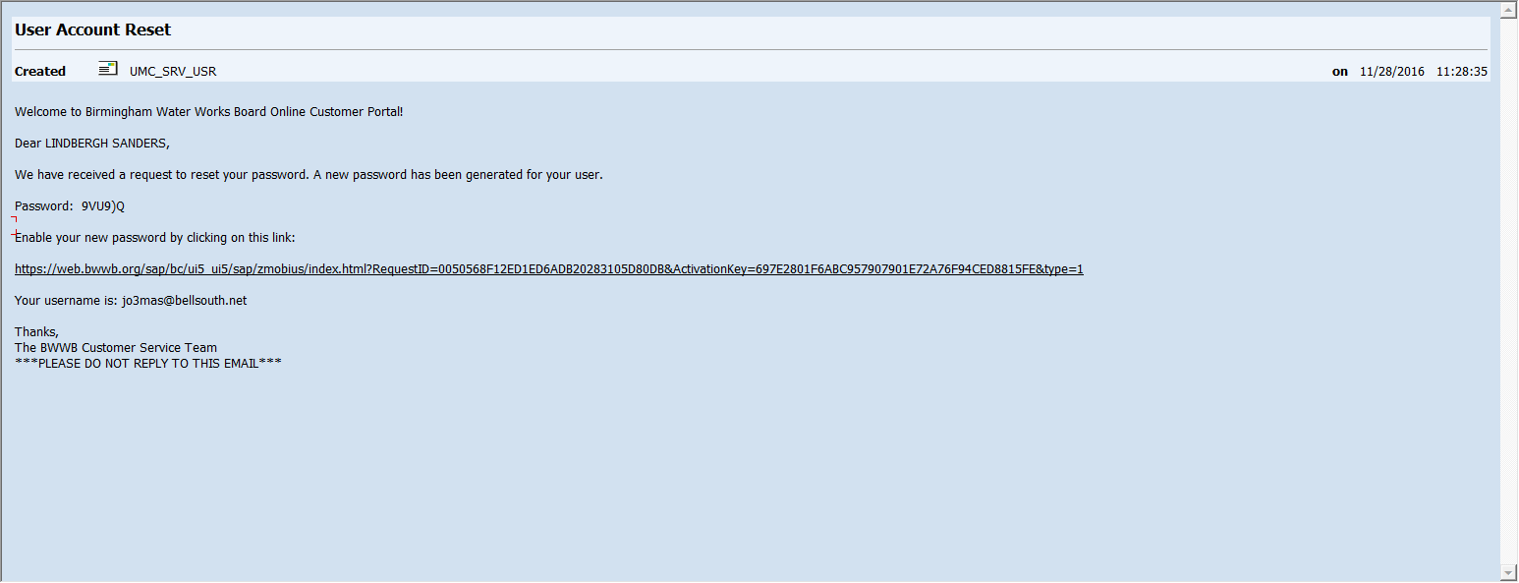

4. “Action Cancelled, User Request is already completed” Error
If customer says they receive an error when they click on the activation link that says “Action Cancelled, User Request is already completed” that means that the customer has already clicked on the activation link and they should enter in the username and password that they created or that is provided in the initial email.
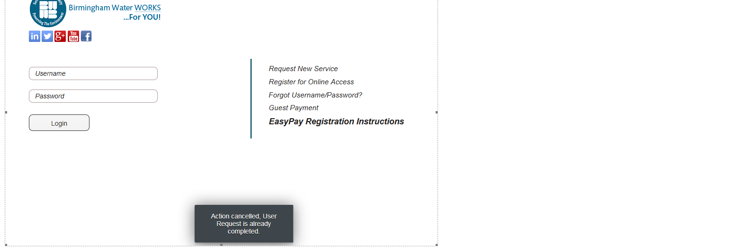

5. Locked out from account
- Log into Mobius agent and pull up the customer’s account by searching by Contract Account or the username that is provided to you in the interaction record tab in ICWEB:
- Click on the Business Partner number (blue font color and underlined)
- 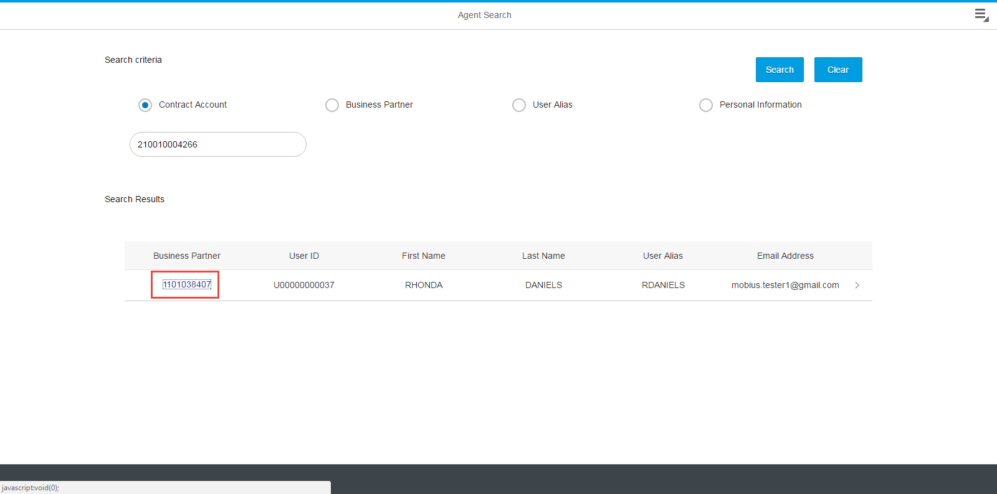
- A screen will be displayed. Click on UnLock and Save.
- 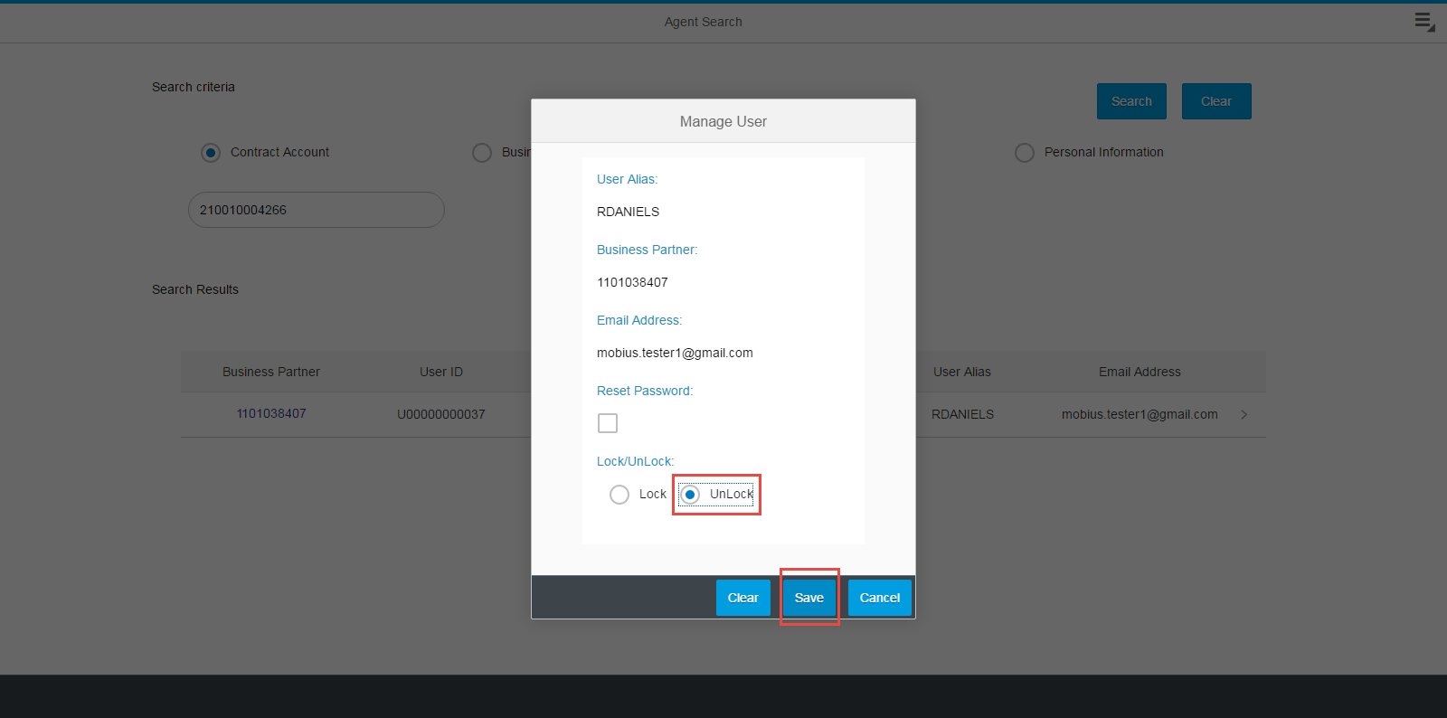
- Customer will then be able to try username and password again. If customer is still getting invalid username or password error. Send them the reset password email from the Mobius agent login by clicking on the box and clicking save.
- 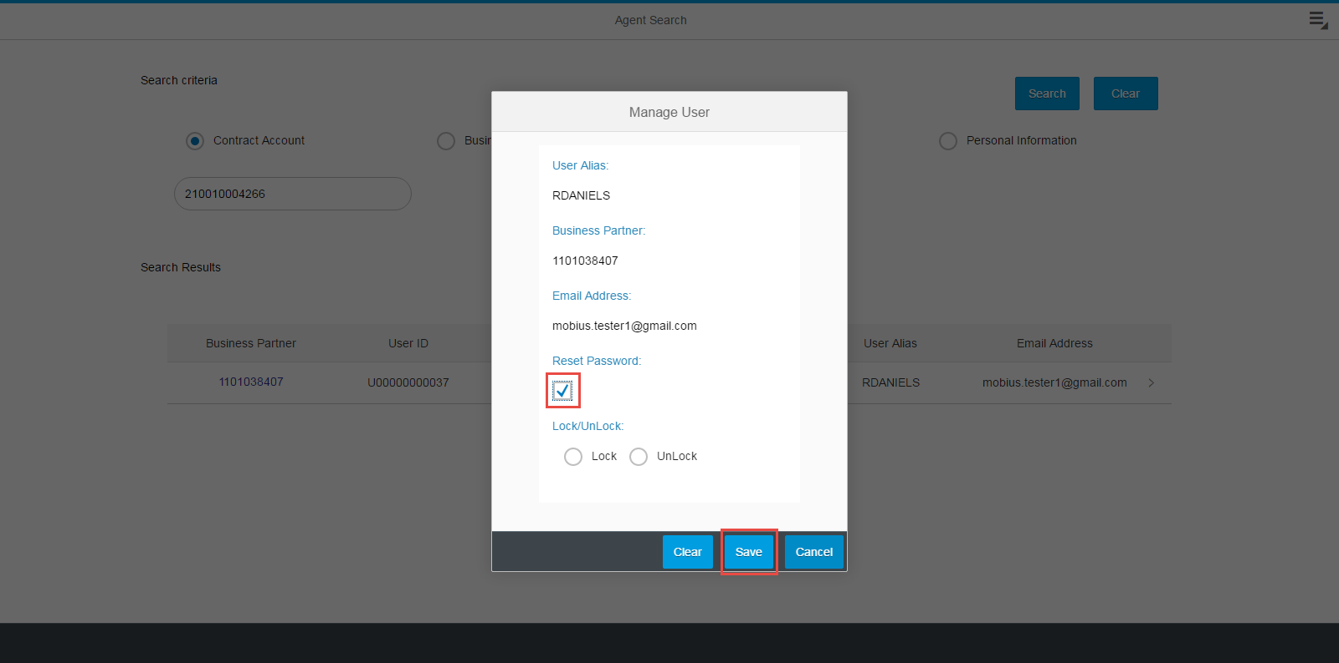

6. Multi-pay
If customers have multiple accounts and they do not want to create a login for each one. Customers can create one login and use the multi-pay option to submit multiple payments. Customers are not allowed to merge accounts under one login like they did before.
Enter in Account Number and Mailing Street #:
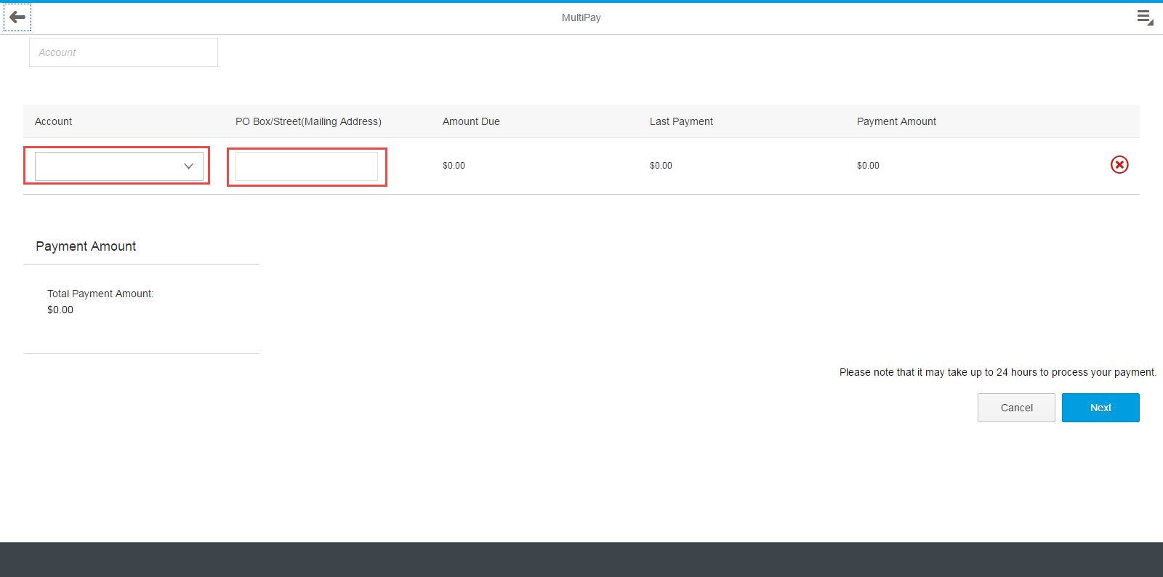
Balances will automatically be displayed and customers can click on the green “+” to add more accounts:
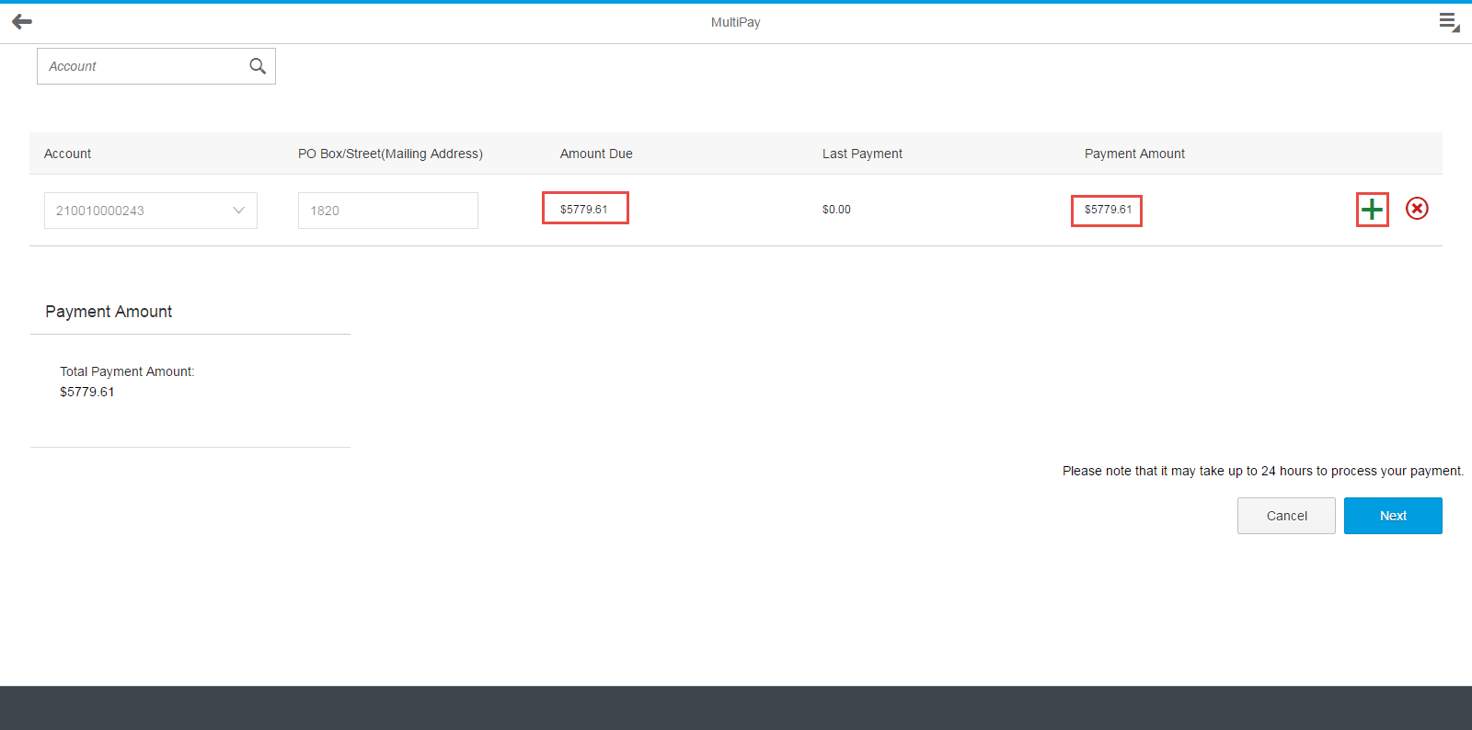

Customers will see all accounts and balances on the screen and they will click next to proceed:
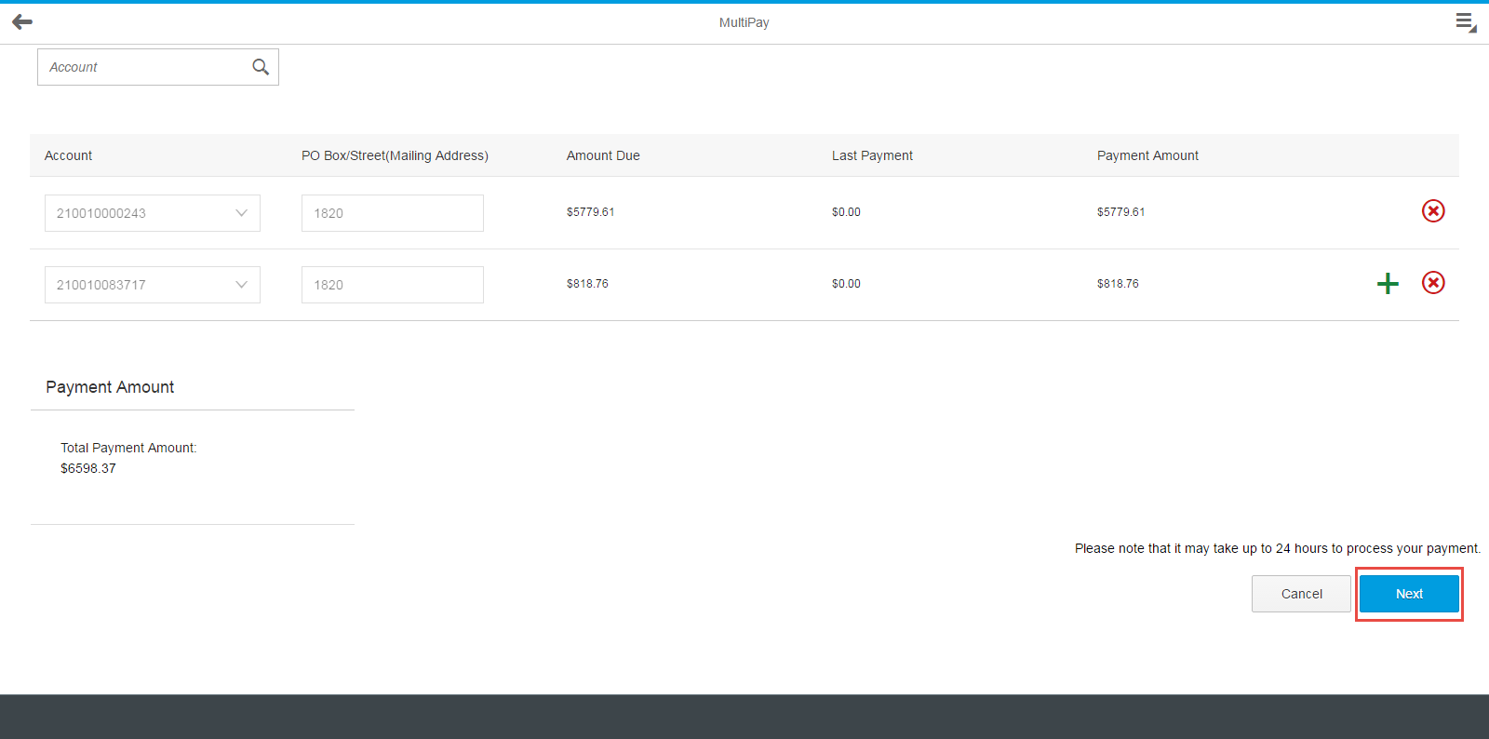
Customers will then click on the boxes to confirm which contract accounts they are going to make a payment for:
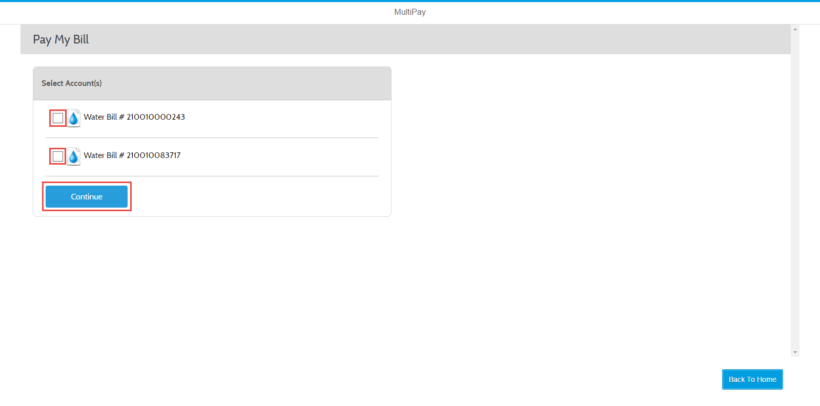

Customers will now be able to edit the payment amount and choose or add payment methods: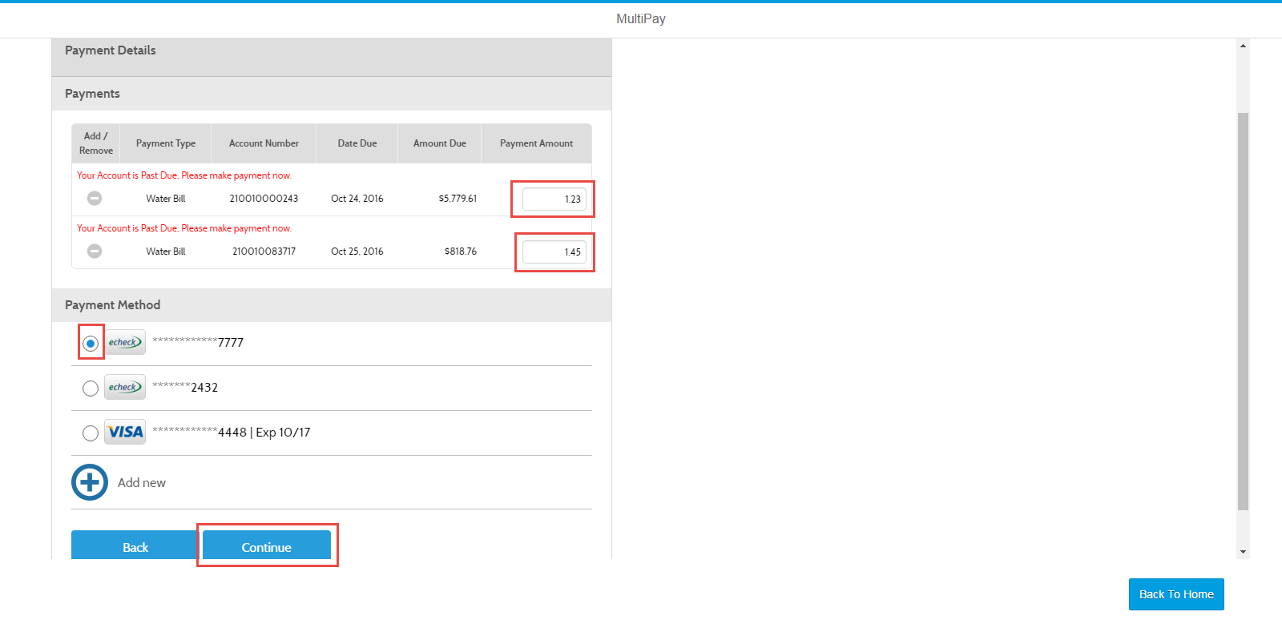
Customers will have to confirm the payment amount and click on pay in order to process multi payments:
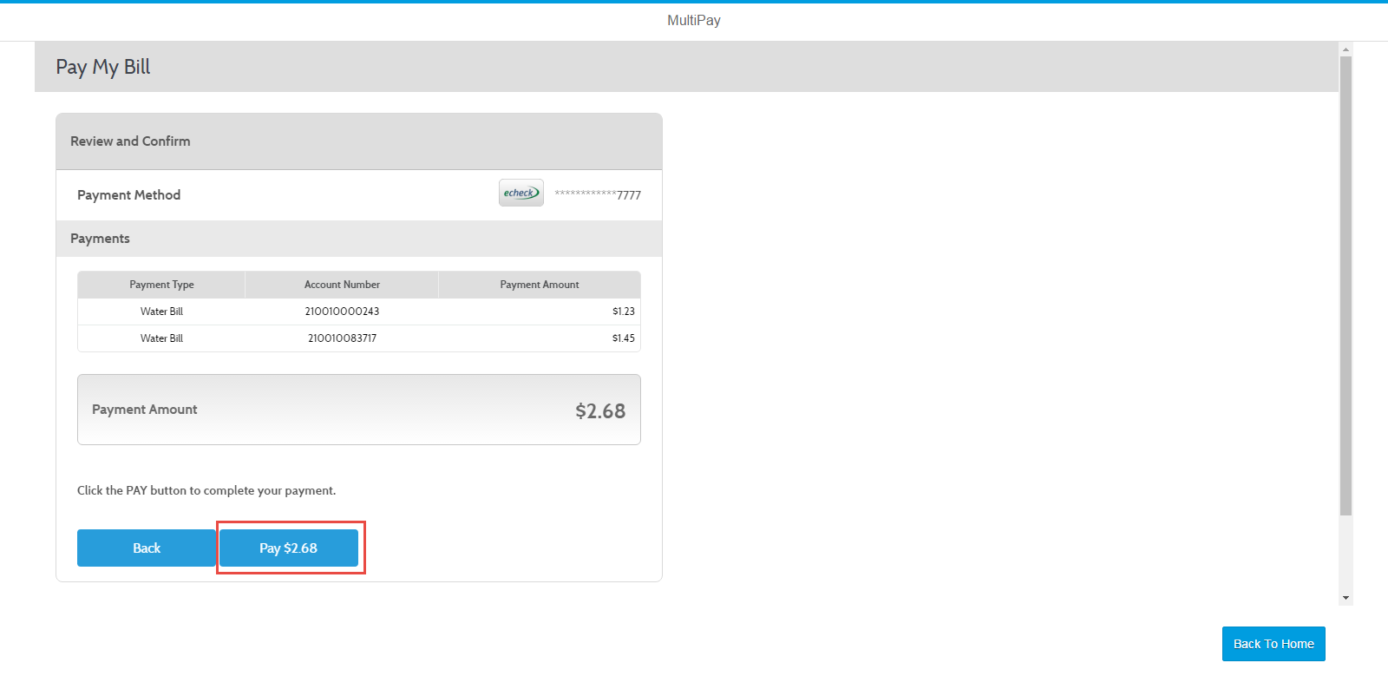
Customers are prompted with a confirmation page: 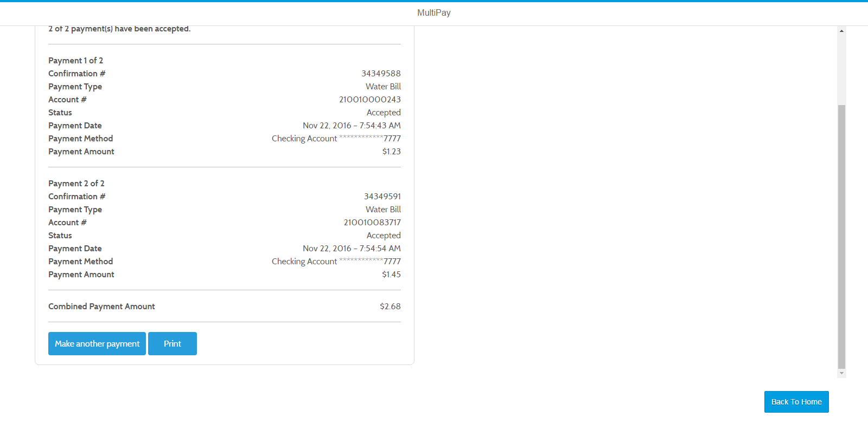

7. Blue screen is being displayed
- If customer calls in and says all they see is a blue screen the customer will need to clear their cache. Please see Clear Cache Document and choose the browser that the customer is using.

8. Link in email is not directing to homepage
- If customers are having issues clicking on the activation link have the customer copy and paste the link into their browser or tell them to hold the Ctrl button down on their keyboard and click on the link and it should display the homepage.

9. Supported browsers

- iOS
  - 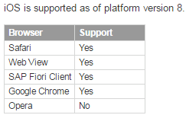
- Android
  - 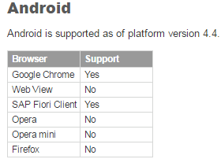
- MacOS
  - 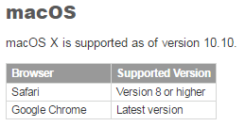

- Windows
  - 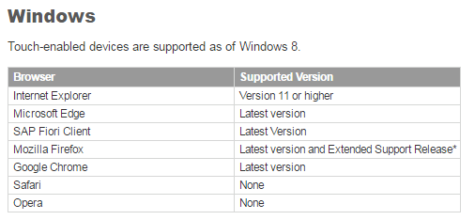
- Windows 10 Mobile
  - 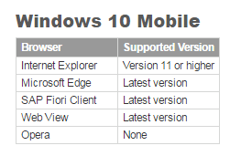

10. Enable/disable paperless billing
- Customers will login and they can only enable (they will not be able to disable) from their home screen:
- 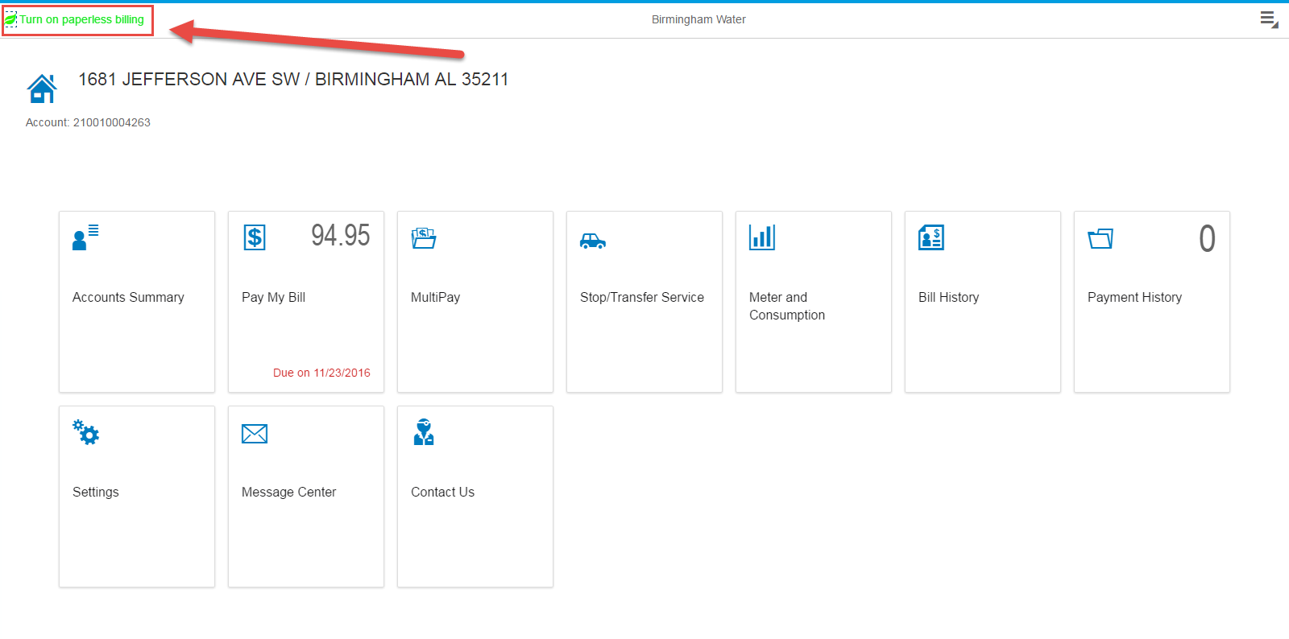
- 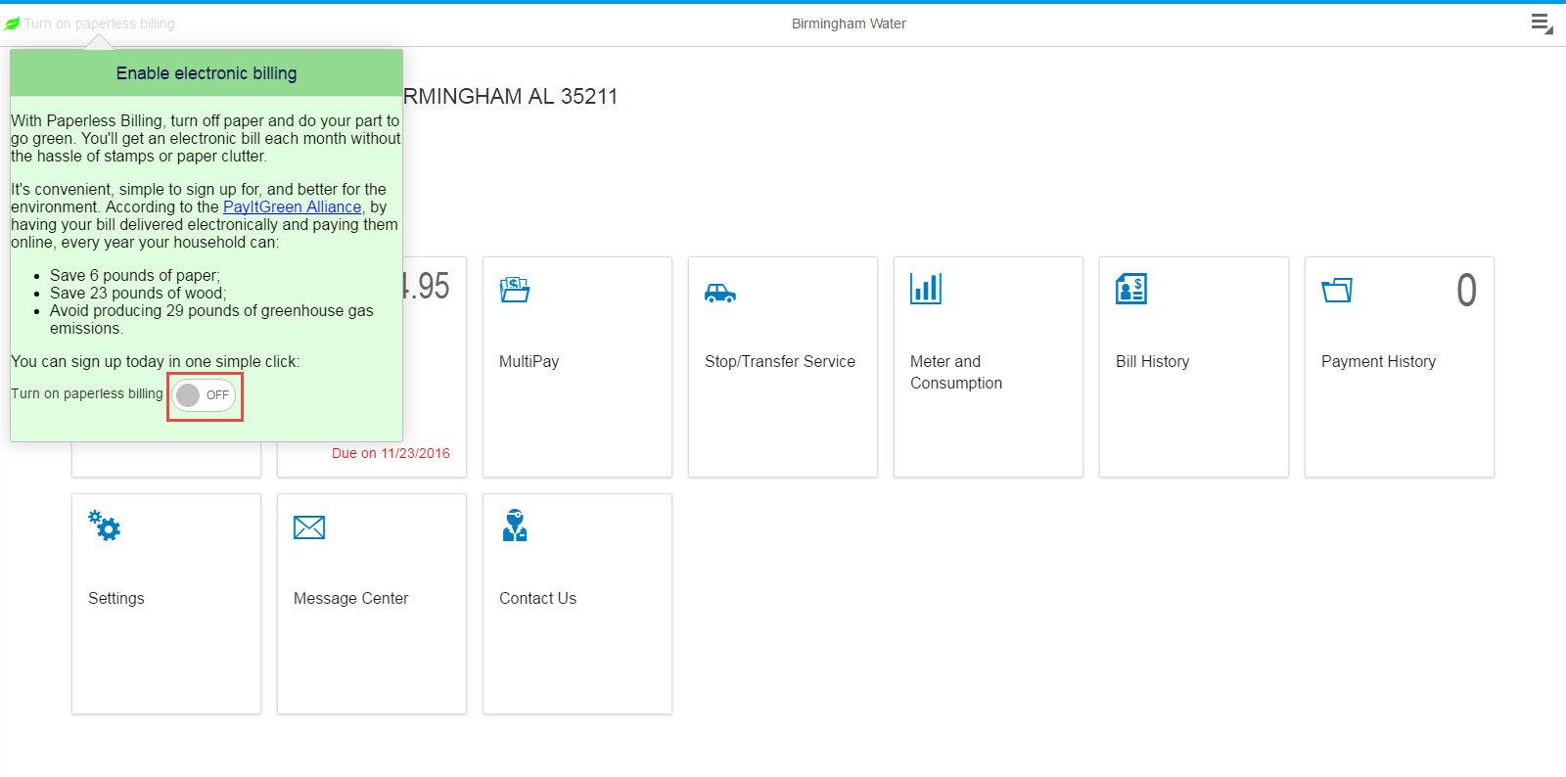

- Customers can enable or disable paperless billing under the settings tile:
- 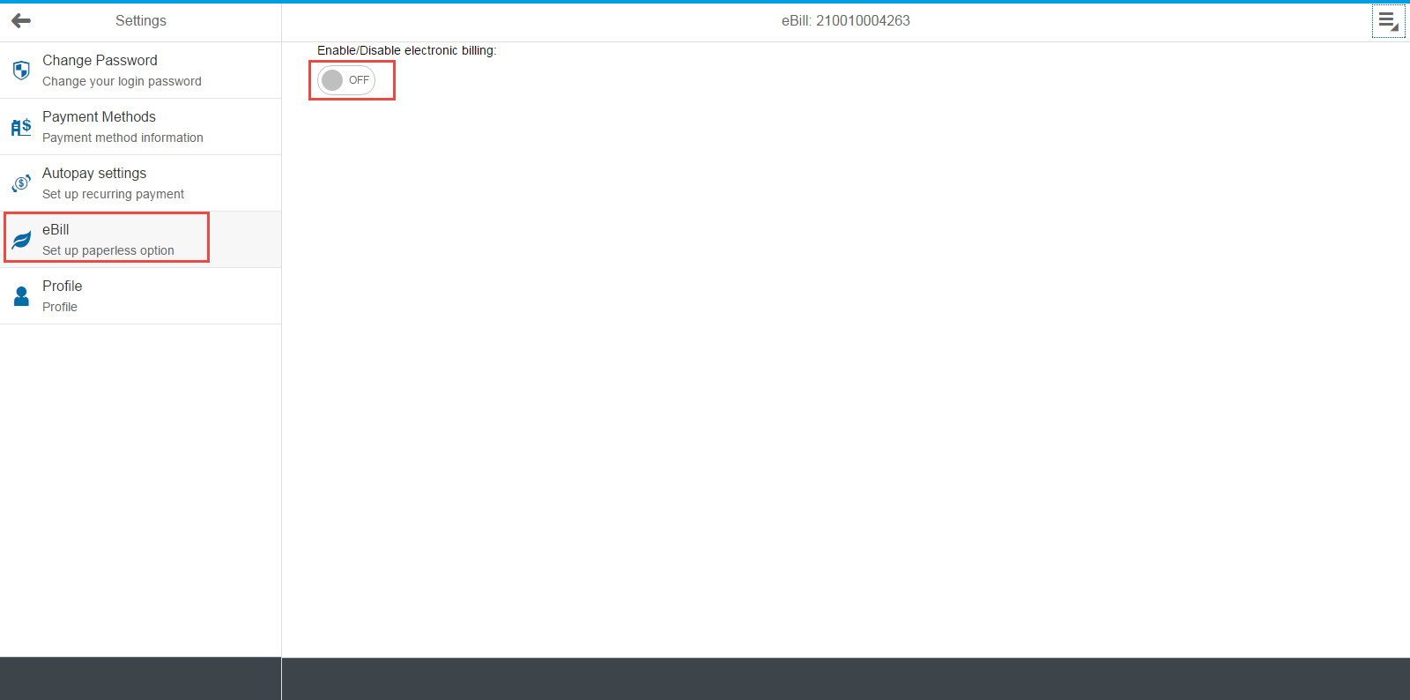
- Those customers that have paperless billing enabled will receive an email on the day their bills are printed.
- Customers will receive this email if they have paperless billing enabled:
- 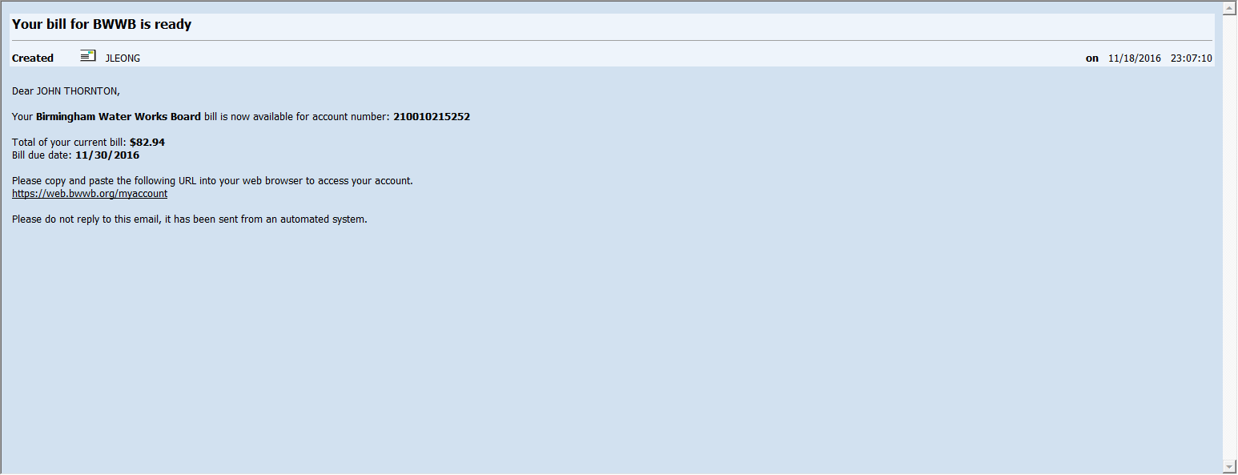

11. Customer wants to enable location services on their MacBook
- Choose System Preferences from the Apple () menu.
- Click the Security & Privacy icon in the System Preferences window.
- Click the Privacy tab.
- If the padlock icon in the lower left is locked (), click it and enter an admin name and password to unlock it ().
- Select Location Services.
- Check the "Enable Location Services" checkbox.
- Source: https://support.apple.com/en-us/HT204690

12. Errors during registration
- If customer attempts to register for online access twice they will not be allowed to submit the registration. Customers will receive the error below.
- 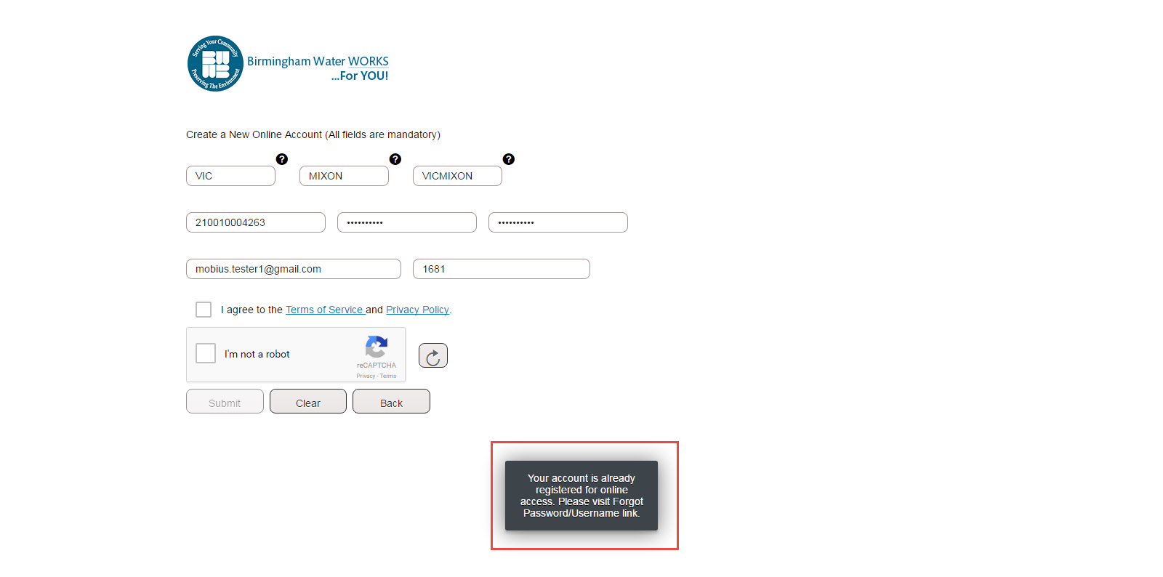
- You will want to give the customer their username by pulling the interaction record or by searching in Mobius agent by their Contract Account number and giving them the ‘User Alias’ under their account number.
- 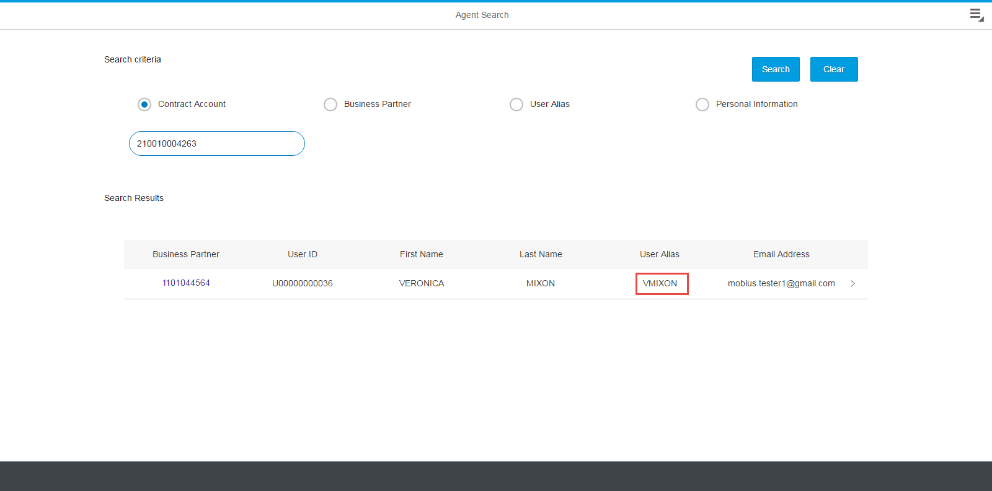

- If customer receives the following error through registration: ‘Value ‘xxxx’ violates facet information ‘maxlength=10’ they are entering the full address in the PO Box/Street # field.
- 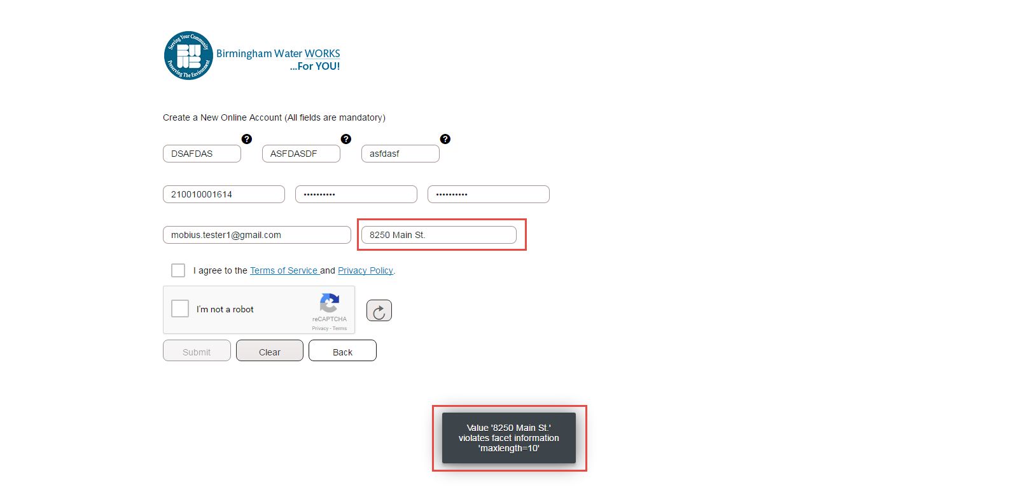
- If customer receives the following error through registration: ‘Username Exists’ they are trying to register with a username and that is already activated in the system.
- 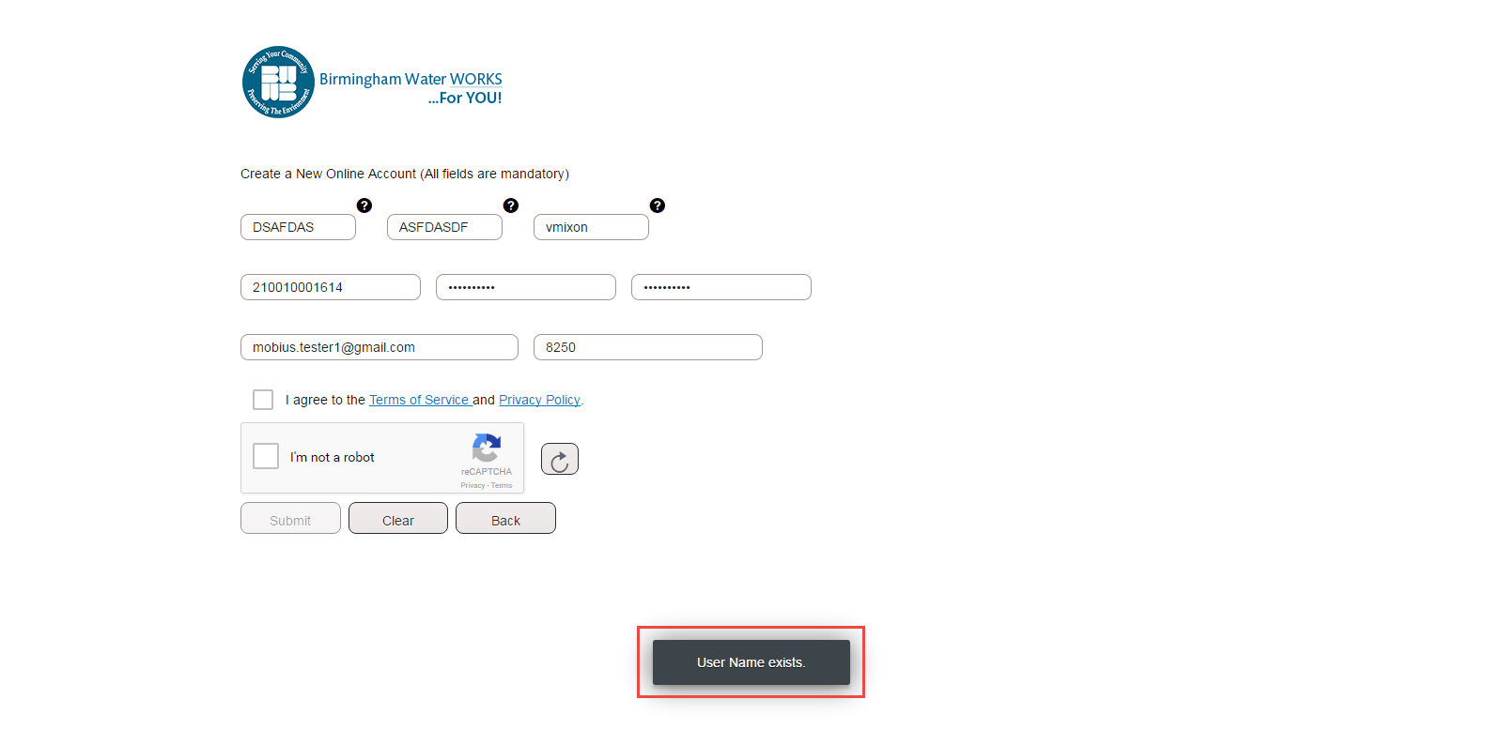

13. Recaptcha does not reload
- When customers call in saying they get an error that says “Verification failed, please refresh reCAPTCHA” tell them they will need to refresh the browser and not just the reCAPTCHA box. This may occur on registration, forgot password, and service requests screens.

14. Submitting Stop, Transfer or Start Requests.
- To submit stop or transfer requests customers must have a registered online account. Customers will receive confirmation emails once they submit these requests.

Stop Request:
  - Click on Stop/Transfer Tile.
  - 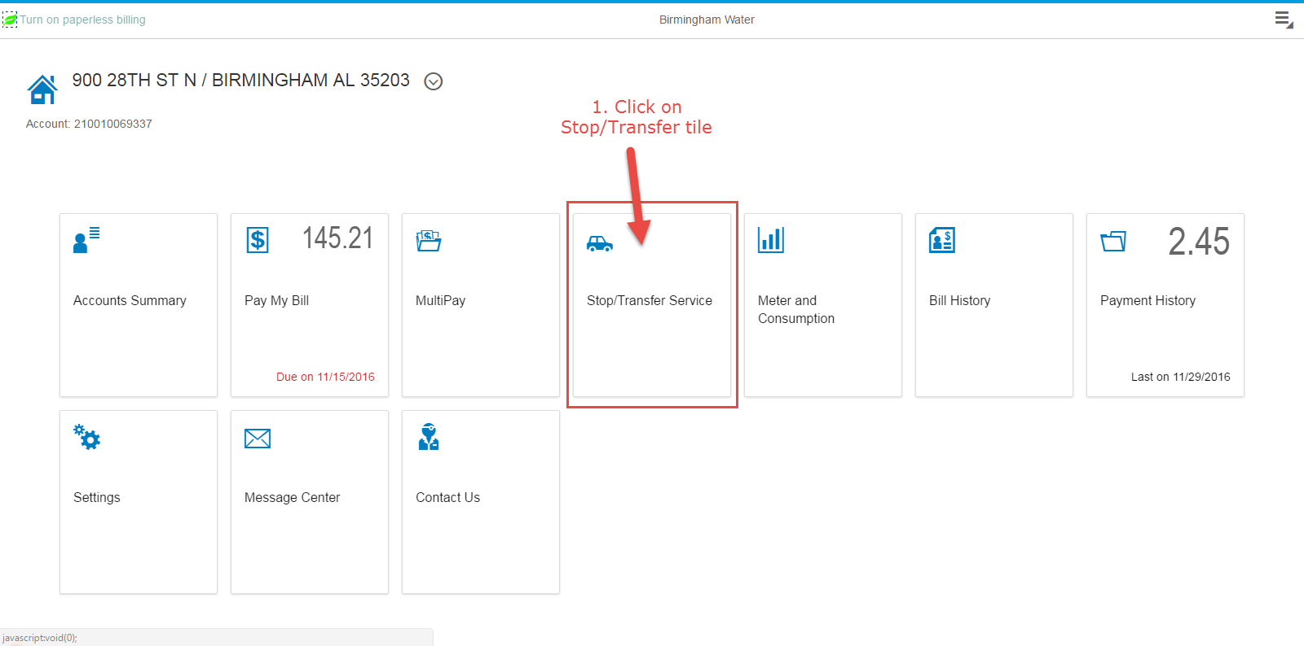
  - Enter stop service date.
  - 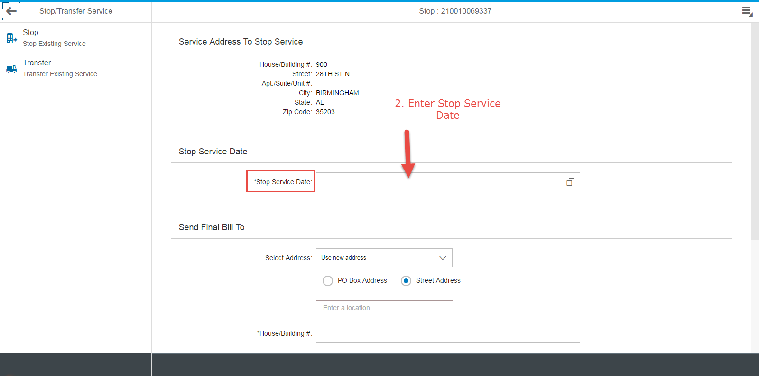
  - Enter final bill address and click on submit.
  - 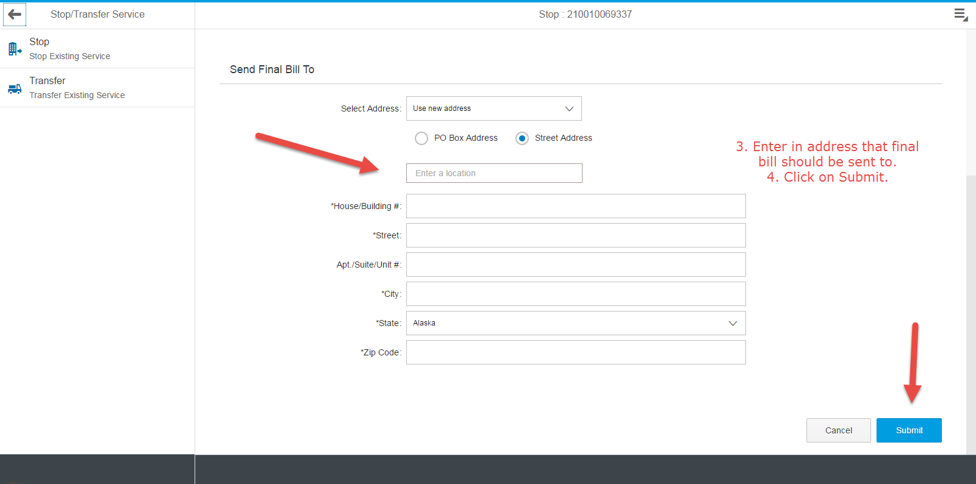
Customers will receive this email after submission:
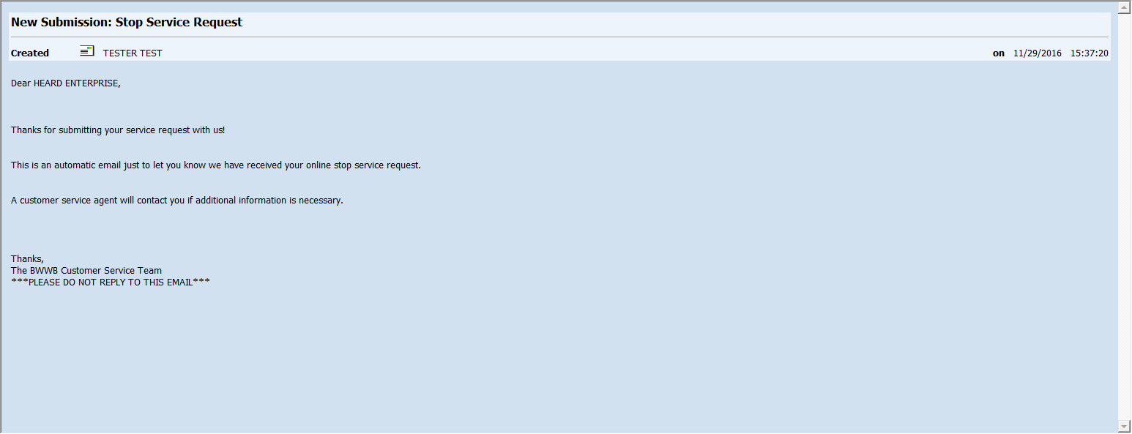

Transfer Request
  - Click on Stop/Transfer Tile.
  - 
  - Enter Stop Service Date and click on the “>” Symbol.
  - 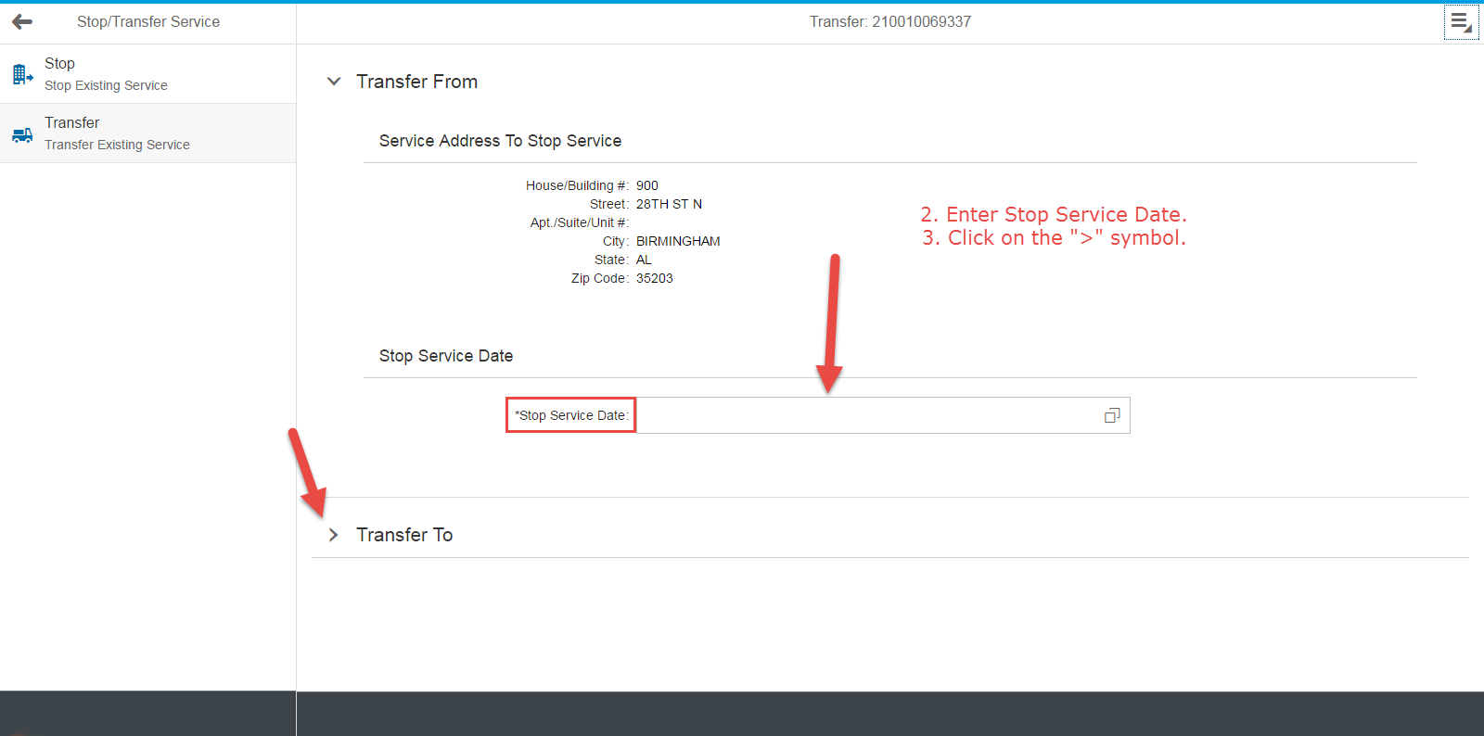
  - Enter new service address and enter start service date.
  - 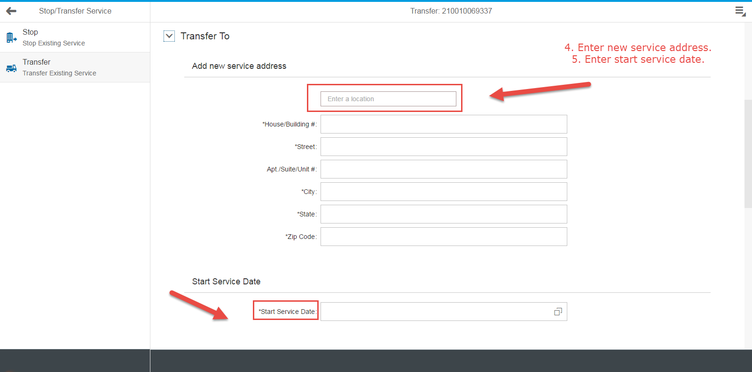
  - Enter Tax ID or SSN and attach copy of deed or lease, enter mailing address for bills, and click on ‘Submit’.
  - 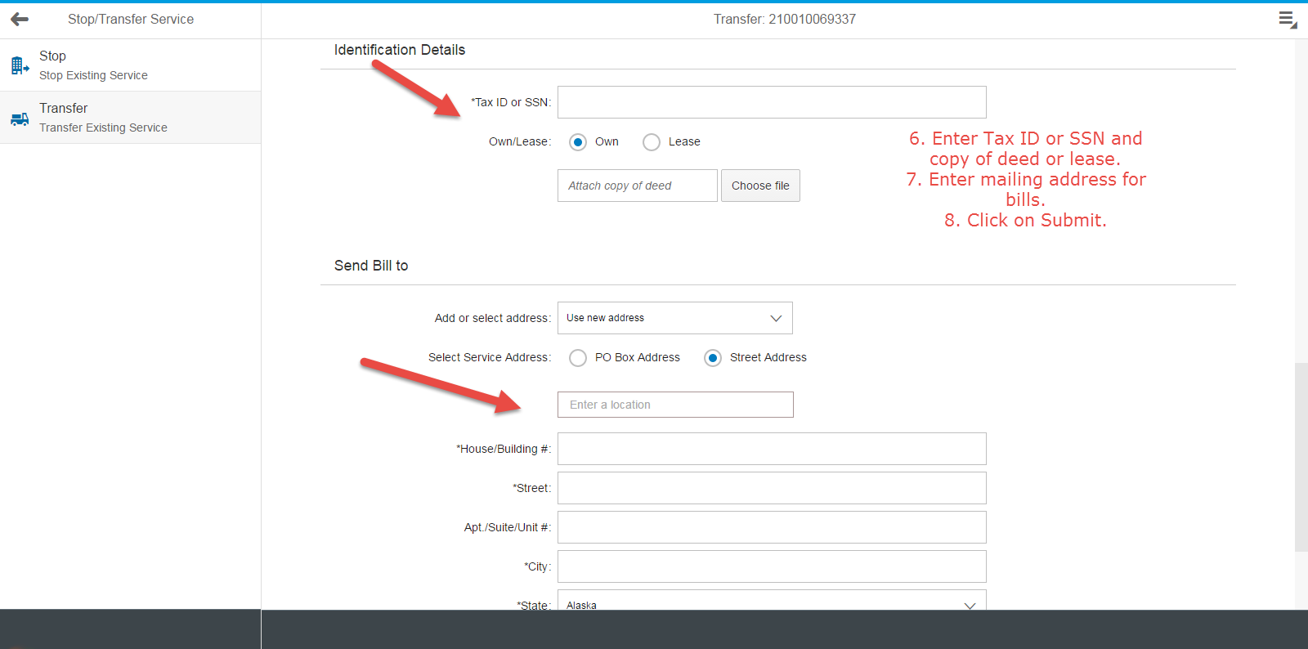
Customers will receive this email after submission:
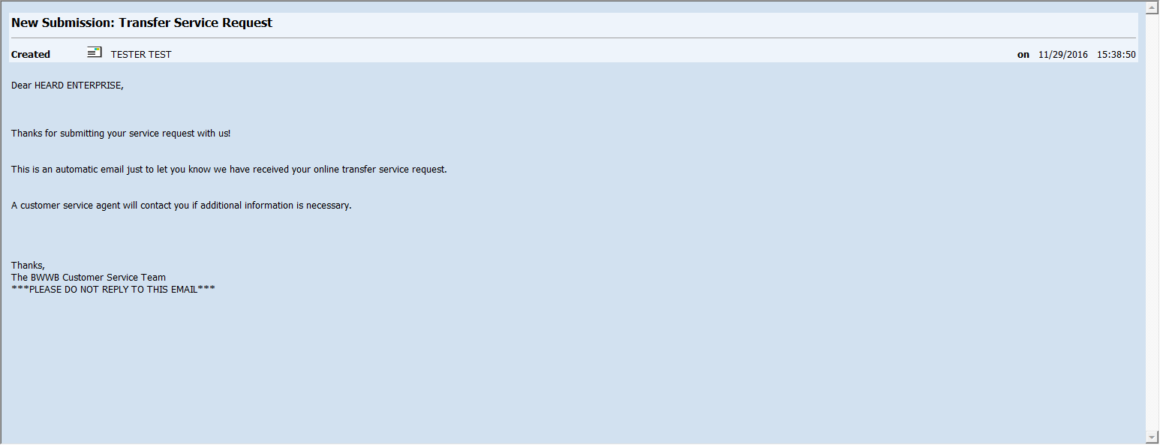

Existing customer starting new services
  - Click on ‘Request New Service’
  - 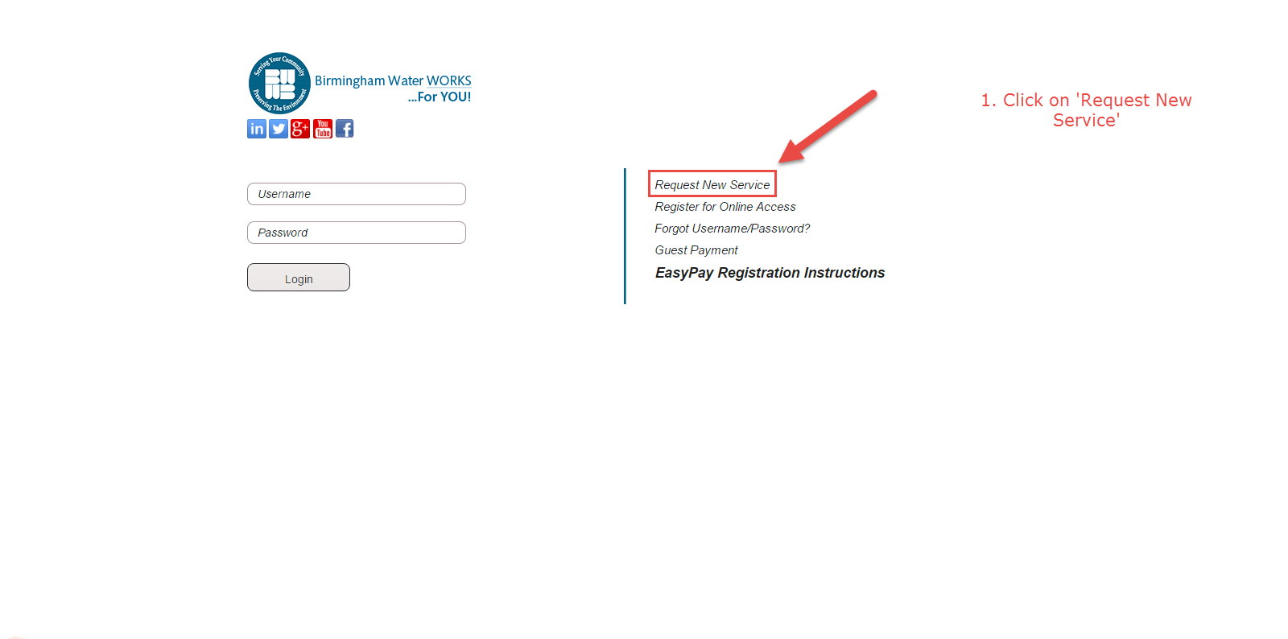
  - Enter existing customer account number and mailing address PO Box/House #.
  - 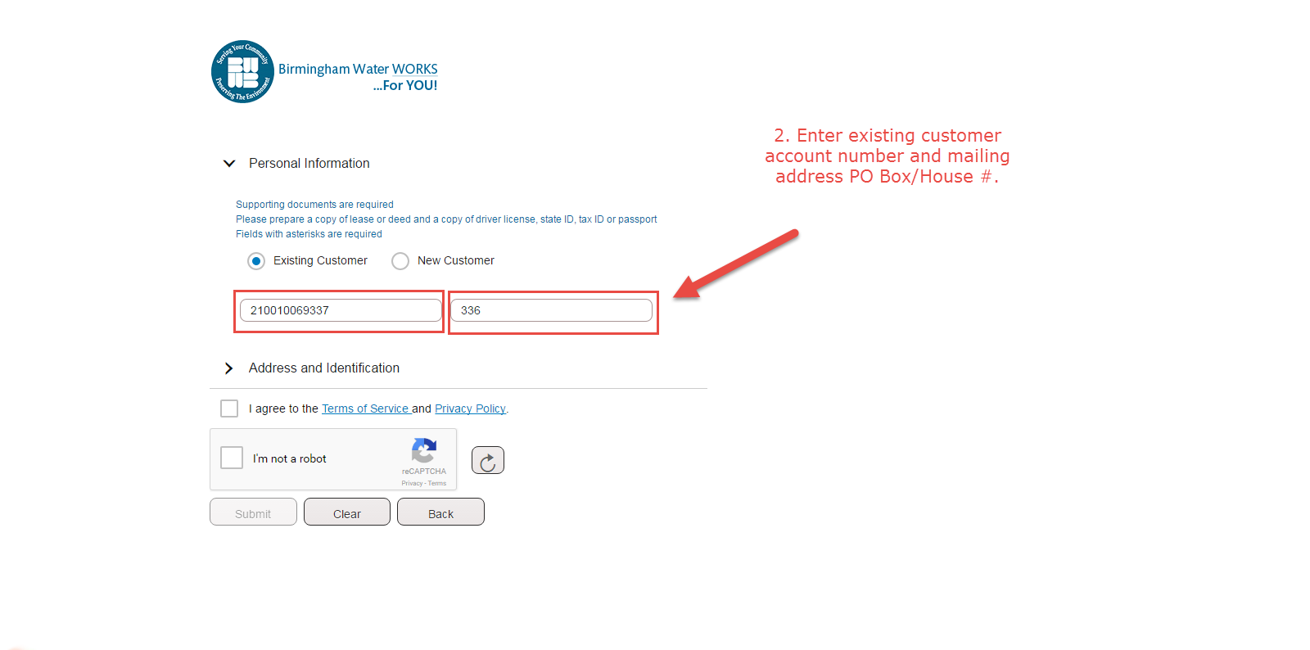

  - Enter in new service address and enter mailing address.
  - 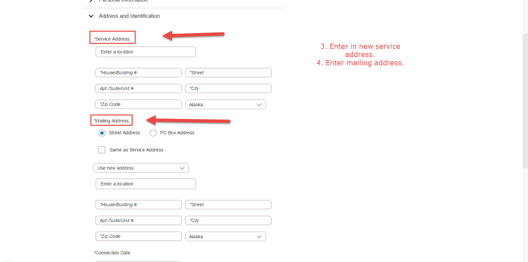
  - Enter in start service date, Enter in Tax ID or SNN #, attach copy of deed/lease and ID. Agree to Terms of Service and check ‘I’m not a robot’ box. Click Submit.
  - 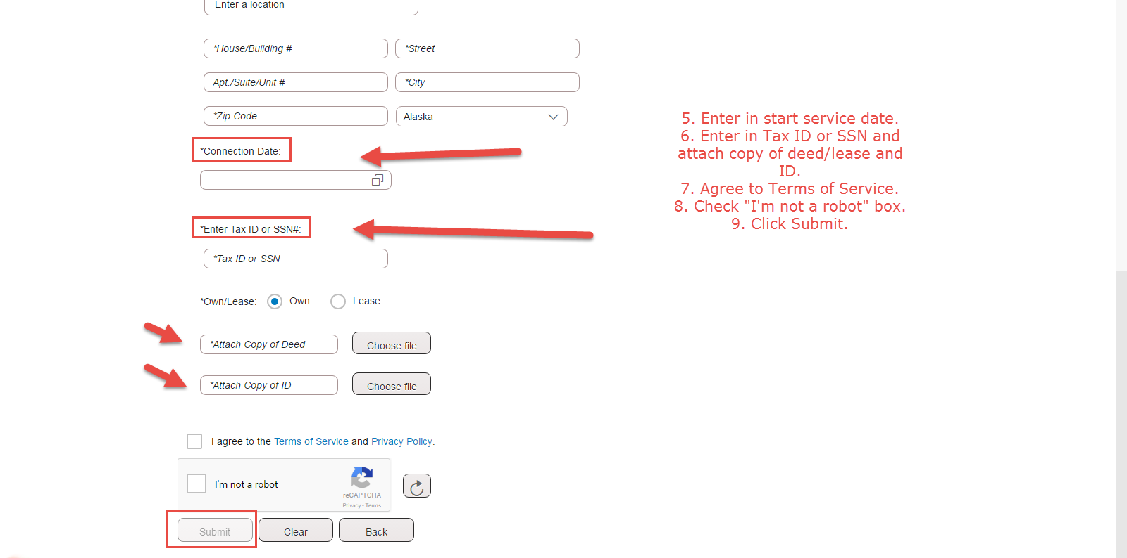
Customers will receive this email after submission:
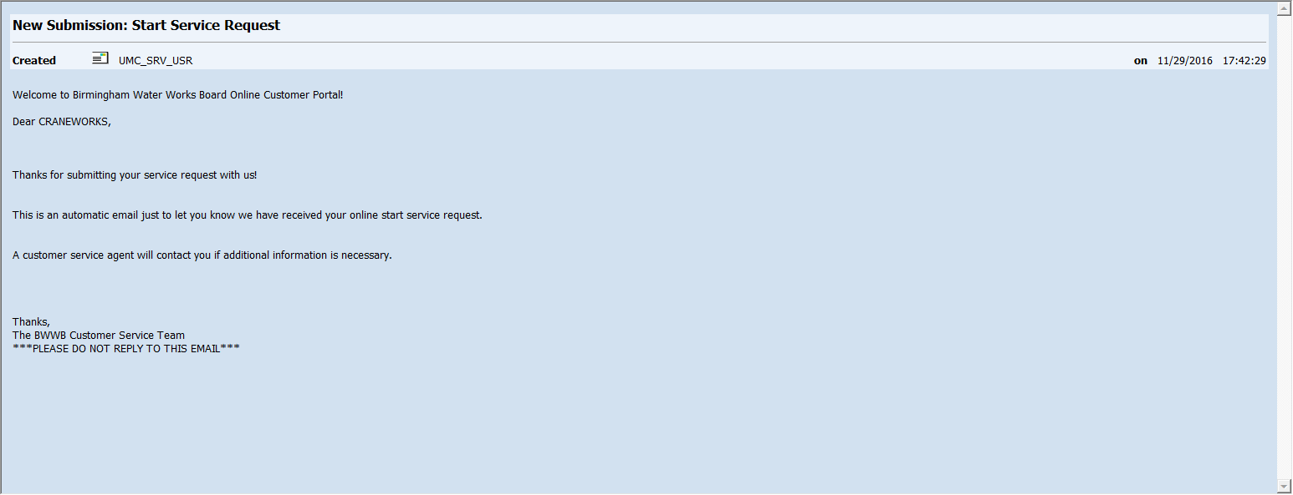

New Customer starting new services
  - Click on ‘Request New Service’
  - 
  - Enter First and Last Name, email address, and contact phone.
  - 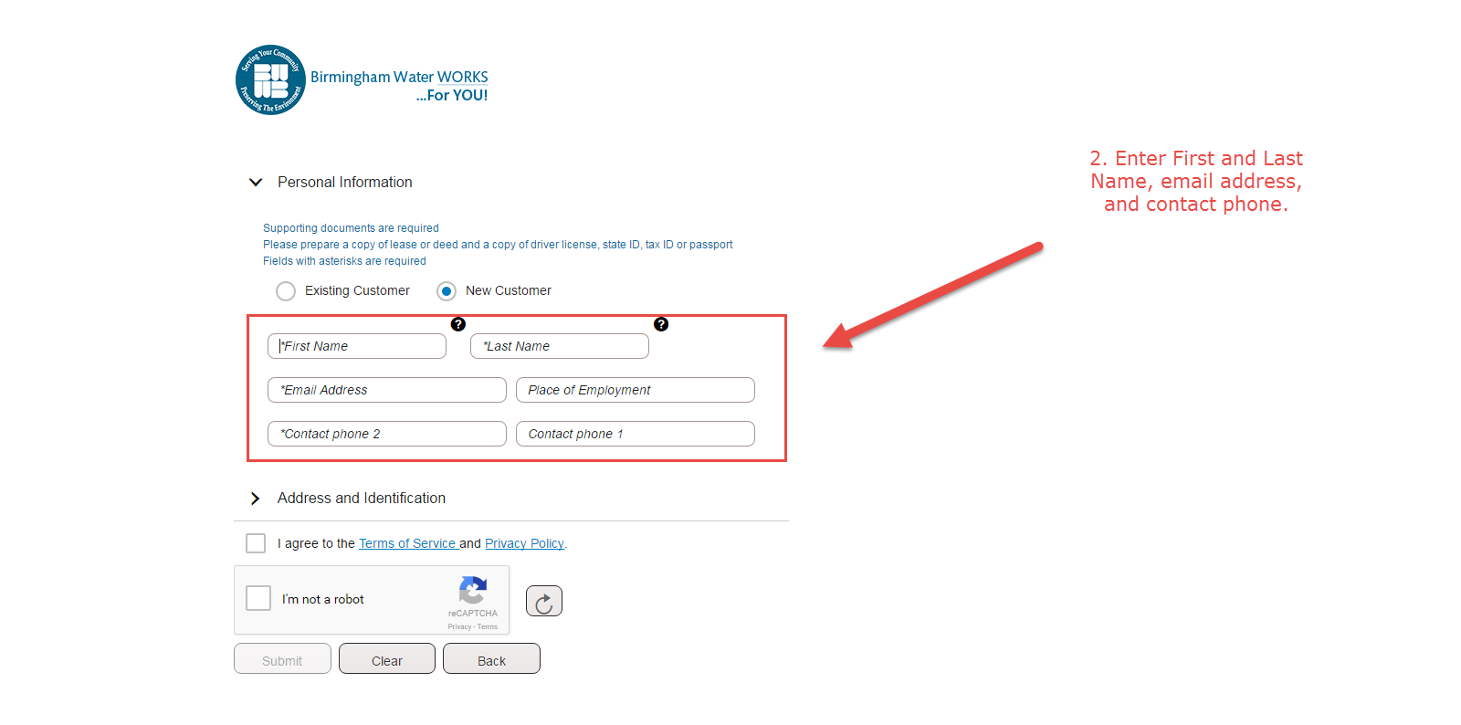
  - Enter in new service address and enter mailing address.
  - 

  - Enter in start service date, Enter in Tax ID or SNN #, attach copy of deed/lease and ID. Agree to Terms of Service and check ‘I’m not a robot’ box. Click Submit.
  - 
Customers will receive this email after submission:
  - 